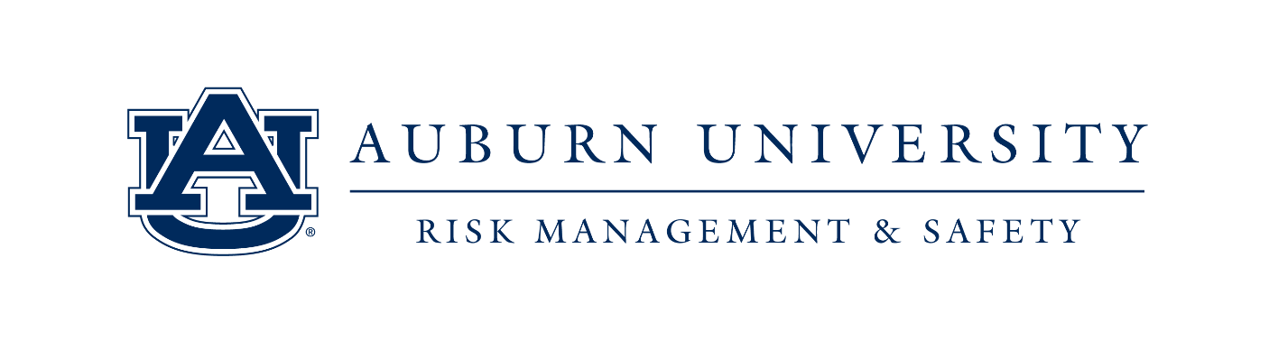

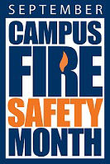
“Campus Fire Safety Month,” founded by the Center for Campus Fire Safety (www.campusfiresafety.org), is a nationwide effort to raise fire and life safety awareness on college campuses throughout the month of September each year. According to the Center, August and September are historically the worst times of the year for fatal campus-related housing fires.

Auburn University Risk Management & Safety (RMS) is currently in its fourth year of participating in the Campus Fire Safety Month awareness efforts. Through our participation, we hope to bring understanding to our 25,000-plus student body (and eventually, the surrounding community) about the dangers of housing-related fires. Students need to be aware of how fire could touch their lives, that fires DO happen in campus-related settings, and that they should take steps to protect and educate themselves about fire safety, no matter their place of residence.

I would like to ask you to consider lending your support for our Campus Fire Safety Month events.
Risk Management & Safety will host multiple awareness activities throughout the month of September, including:

- Campus Fire Safety on the Concourse – Hands on training and teaching for Auburn University students
- FireSmarter GameShow – Students test their fire safety knowledge for prizes
- Popcorn and Prevention – Using a fun and unique avenue (microwave popcorn) to promote cooking safety
- Fire Extinguisher Training (part of SGA Safety Week) – A state of the art simulator and trainer
- Stay Fire Safe – An in-depth training, resource, and planning event with door prizes and more

Last year’s Campus Fire Safety Month efforts at Auburn University were a success, but for September 2019, we wish to expand the event, bringing this all-important safety message to even more young minds! Your support will encourage greater involvement from our student body, which in-turn, will help make Auburn University’s campus a safer place for students to live and learn. In addition, your brand will be aligned with a nationally recognized awareness initiative, focused on the education and safety of our country’s future generations.

Our essential areas of needed support for these events include food, beverages, printing materials and give-away items. Any support you can offer will be greatly appreciated. As a token of our appreciation for your generous
donation, your organization/business logo will be featured on our advertising materials and Campus Fire Safety Month webpage.

Thank you for your time, and I look forward to working with you to make Auburn University’s Campus Fire Safety Month a success. If you have any questions, please feel free to email or call me. For more information, please visit our Campus Fire Safety Month webpage (aub.ie/CampusFireSafety).

Sincerely,

Kevin Ives
Auburn University Risk Management & Safety
pki0002@auburn.edu
1161 West Samford Ave RMS Building 9
334-844-2502 (Office)
334-750-1555 (cell)

