

STUDENT PATIENT HANDBOOK

HOURS

FALL / SPRING TERM
Monday | 8:00am – 6:00pm
Tuesday | 8:00am – 6:00pm
Wednesday | 8:00am – 6:00pm
Thursday | 9:00am – 6:00pm
Friday | 8:00am – 5:00pm
Saturday | 8:00am – 12:00pm
Sunday | CLOSED

SUMMER TERM
Monday | 8:00am – 5:00pm
Tuesday | 8:00am – 5:00pm
Wednesday | 8:00am – 5:00pm
Thursday | 8:00am – 5:00pm
Friday | 8:00am – 5:00pm
Saturday | CLOSED
Sunday | CLOSED
*CLOSED DAILY from 12:00 – 1:00*

Please note – The AU Medical Clinic is operated based on the Auburn University academic calendar and hours are subject to change accordingly.

LOCATION

We are located at 400 Lem Morrison Drive on Auburn’s campus. The Clinic is accessible via the Tiger Transit’s South Quad – East Campus line. There is parking available at the clinic for PATIENTS ONLY.
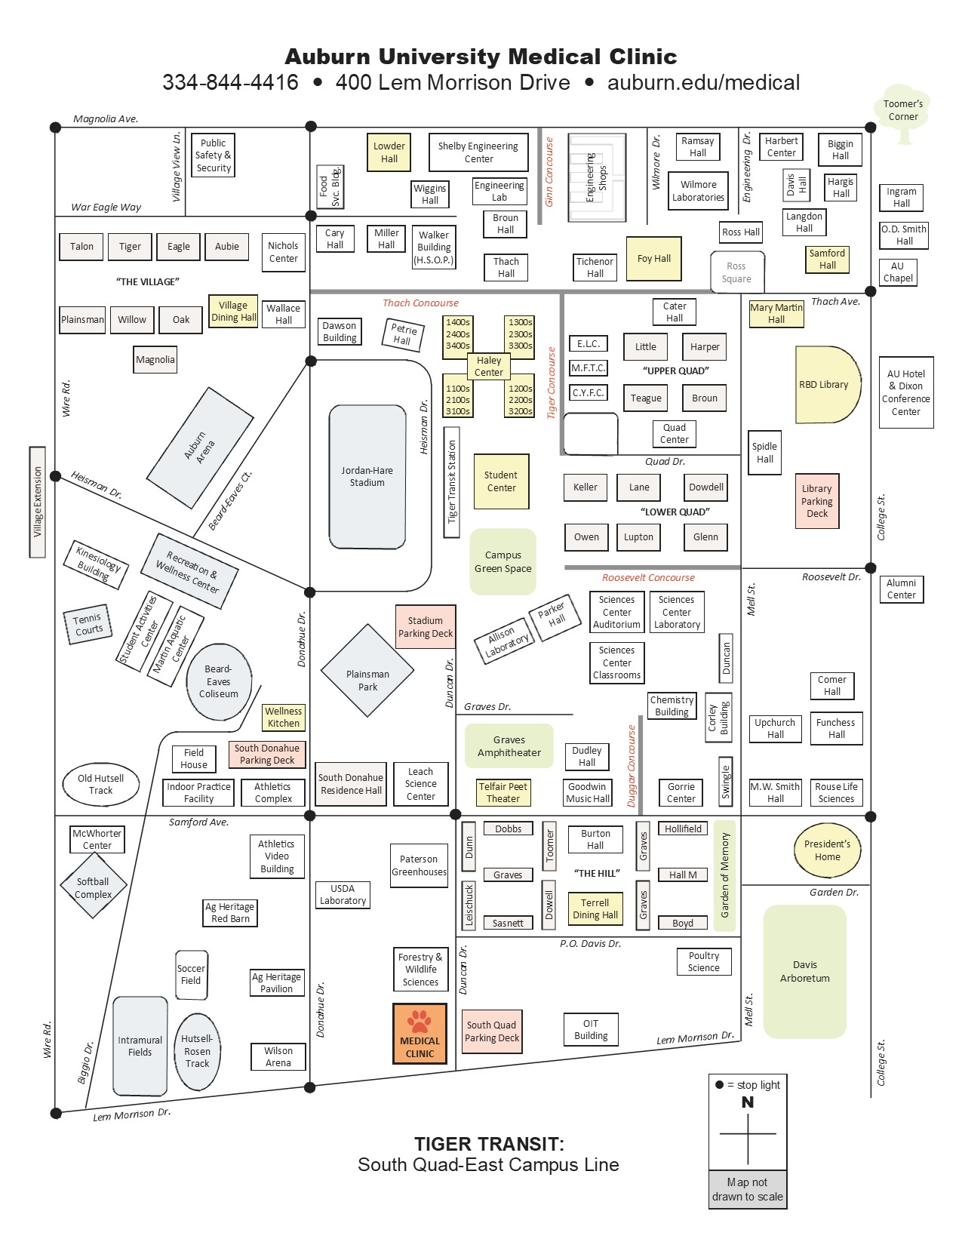
CONTACT INFORMATION

Appointment & Registration | 334-844-4416
Billing & Insurance | 334-844-6137
Fax | 334-528-5416
Nurses Station | 334-844-6125
Student Pharmacy | 334-844-4641
Massage Therapy | 334-844-6237
Miller Clinic (Chiropractor) | 334-844-7651
COVID Hotline | 334-844-9825
Student Counseling Services | 334-844-5123
Safe Harbor (Sexual Assault) | 334-844-7233
24/7 Nurse Line | 855-201-0107
Auburn Medical Pavilion  (EAMC Freestanding Emergency Department) | 334-364-3000

SERVICES

Acute/Urgent Care –
- We offer primary, preventative, and urgent care. Care is provided by our team of fully licensed and board-certified physicians, nurse practitioners and physician’s assistants.

Immunizations –
- We offer a wide range of vaccines, from routine vaccines to vaccines for international travel. Some of these vaccines can be done on a walk-in basis, dependent on the vaccine and the need for the vaccine. Walk-in vaccines are done from 8:00am - 11:00am or 1:00pm -4:00pm.

- It is important to make sure an appointment with a doctor is not needed BEFORE the patient does a walk-in visit.

- If a patient is currently taking allergy shots prescribed by an allergist, those shots can be administered at our clinic. It is the patient’s responsibility to have the allergy serum and instructions sent to our clinic, or the patient can bring the serum with them when they arrive in Auburn. The serum can be mailed to:
400 Lem Morrison Drive
Auburn University, AL 36849

Allergy shots are only administered Monday, Tuesday, Wednesday, and Friday between the hours of 8:00am – 11:00am or 1:00pm – 4:00pm.

Laboratory –
- We have a convenient on site CLIA certified lab, staffed with licensed medical technologists.
- If you need blood tests to monitor care from another provider, they can be done in our lab with an appropriate written order from your physician.

X-Ray –
- We offer X-rays on site, provided by a licensed medical technologist. All X-rays are reviewed by a licensed radiologist.
- A digital copy of the X-ray is available to the patient for a fee.

Chiropractic –
- Dr. Miller and his staff provide both manual and instrument assisted adjustments using low force techniques.
- They treat acute injuries, non-surgical musculoskeletal conditions, and help manage chronic pain.
- The Miller Clinic offers custom orthotics made in their on-site orthotics lab.

Women’s Health –
- Professional services are provided by our medical doctors and Advanced Practice Providers (Nurse Practitioners and Physician Assistants).
- Services include routine gynecological care, counseling, and prescribing birth control methods (this does not include placement or removal of IUD), and diagnosis and treatment of STDs.

Massage Therapy –
- Massage Therapy has proven to be more than just a “luxury,” it is a valuable component of a well-rounded and healthy lifestyle. There are many services available, including medical/therapeutic, Swedish, trigger point, hot stone, reflexology, and more.
- AU Massage Therapy is open to the public as well as students and faculty.
- Services and pricing are listed on their website: www.auburn.edu/massagetherapy

Mental Health –
- Mental health services are provided in collaboration with Student Counseling Services.
- Student Counseling services is located on the second floor of the medical clinic.

Student Pharmacy –
- The Student Pharmacy is located in the lobby of the medical clinic for ease and convenience of getting prescriptions filled by students.
- Pharmacy charges can be billed to E-bill.

COVID-19 Testing, Treatment & Vaccines –
- COVID testing is available in the form of the rapid antigen test and a PCR test.
- Appointments for testing can be made by calling (334) 844-9825.

SCHEDULING APPOINTMENTS

It is encouraged that patients call the appointment line, (334) 844-4416 to schedule an appointment. Our registration representatives will assist the patient in getting an appointment in a timely manner in hopes to minimize the wait time when visiting the clinic. Walk-ins will be evaluated and given an appointment time or seen immediately, depending on the urgency of their condition.

FINANCIAL RESPONSIBILITY

The Auburn University Medical Clinic is a fee-for-service facility, meaning you pay for medical services only when you use them. We will file insurance when applicable. Copayments are due at the time of the visit and can be paid by card, cash, or check. We cannot charge to a student’s E-Bill. Once insurance payments are received, remaining balances will be the patient’s responsibility. Statements will be sent to the address on file, provided by the patient. These balances can be paid in person, by phone or online through the patient portal or Pay My Doc. Payment plans are available for students; this must be discussed and set up with the AU Medical Clinic billing department.

We have contracts with MOST major medical insurance companies; however, it is the patient’s responsibility to ensure coverage at our facility. You can check coverage by calling the member services number on the back of your insurance card.
Common Plans that DO NOT cover at our facility:
- Any insurance plan that has HMO on it
- Medicaid (may go by a different name in other states)
- Medicare
- Tricare Prime
- AVMED
- Optum
- AmeriHealth
- Bright
- Christian Ministry or any other “sharing plans”
- Oscar
- GHI
- Health Net
- Kaiser Permanente
- Medishare
- Liberty Share
- Care Connect
- AAP
- Affordable Care Act plans that do not cover out of state
- Blue Cross Blue Shield Out of State – make sure it covers in Alabama under a PPO Plan

**PLEASE CHECK WITH YOUR INSURANCE PROVIDER TO DETERMINE IF YOUR VISIT WILL BE COVERED**
TAX ID: 80 0278187 (East Alabama Campus Health)

We will not deny service to any student, even if their insurance is not in network with the AU Medical Clinic. We will send out statements for any/all balances a student incurs.
PATIENT PORTAL

Students will receive an invitation to the patient portal once they are entered into our system. The portal can be accessed through an app called Follow My Health. On the app, the patient can access lab results, a summary of care received, see a list of vaccines given at the AU Medical Clinic, view medical issues and allergies, and request appointments.

ADD/ADHD RX REQUIREMENTS

Patients MUST provide the AU Medical Clinic with testing records, or a letter from a psychiatrist stating that the patient has been diagnosed with ADD or ADHD. These records must be reviewed and approved by one of our physicians before the patient can make an appointment. This process can take up to 7 days to complete. A member of our clinical staff will contact the patient when the status is updated to approved, or if we need more information.
ADD/ADHD prescriptions require a follow-up with a physician every 3 or 4 months. The follow-up is at the discretion of the physician.
Prescription refills can be done on the patient portal and are E-Scribed to the pharmacy on file. Please allow 48-72 hours for the information to update in our system. Also allow 48-72 hours for the refill request to process.

HIPAA COMPLIANCE

Any patient 19 years or older is protected by the HIPAA laws, meaning we cannot give out any information on the patient unless consent is given by the patient.
A patient can give the medical staff either verbal or written consent for information to be shared with an individual at any time. This consent must be done on a visit-by-visit basis and must be initiated by the patient.

We do not offer a blanket release to cover the patient for an extended period of time.

