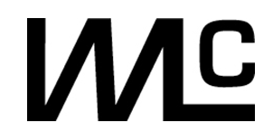
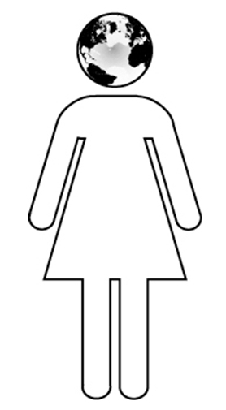
Women of Distinction
Nomination Form
FACULTY
Each year at the Women’s Leadership Conference, Auburn University honors a faculty member who demonstrates exemplary leadership abilities. She leads with heart, creating innovative solutions, while inspiring and uplifting the entire Auburn University Community.
The Women’s Leadership Conference is seeking to honor a female leader who awakens the passion for success of those around her. She encompasses the ideals of a successful leader, radiating a demeanor that compels others to do the same.

‘13

NOMINEE INFORMATION

Nominee: | Click here to enter text.
School/College: |  | Click here to enter text. |  |  |  | Department: | Click here to enter text.
Years at Auburn: |  | Click here to enter text. |  | Title: | Click here to enter text.
Degrees Held/Granting Institution(s) |  |  | Click here to enter text.
Phone Number: |  | Click here to enter text. |  | Email Address: |  | Click here to enter text.

IN 500 WORDS OR LESS, PLEASE ADDRESS THE FOLLOWING QUESTIONS AND ATTACH TO FORM:

- What unique leadership skills does the nominee possess that set her apart from her peers?
- Please describe those achievements the nominee has accomplished within or beyond Auburn University that demonstrate creative, compassionate, and innovative leadership.
- How have these achievements impacted and inspired you?
- In particular, describe how the nominee has been an inspiration to the other women at Auburn.

~ Please include a copy of the candidate’s CV or resume. ~

IN ADDITION, PLEASE CONTACT ONE OTHER PERSON TO SEND A LETTER OF SUPPORT
FOR THIS NOMINEE AND PROVIDE HIS/HER CONTACT INFORMATION BELOW.

Name/Organization |  | Click here to enter text.
Relationship to the Nominee: |  |  | Click here to enter text.
Phone Number: | Click here to enter text. |  |  | Email Address: | Click here to enter text.

NOMINATOR INFORMATION:
Name/Organization |  | Click here to enter text.
Relationship to the Nominee: |  |  | Click here to enter text.
Phone Number: | Click here to enter text. |  |  | Email Address: | Click here to enter text.

Return completed application by 4:45 p.m. on Friday, February 22, 2013 to:
Women’s Resource Center, 311 Mary Martin Hall
or via email to kmm0021@auburn.edu (Call 334-844-4289 with any questions)

