Food Chains, Food Webs and Energy

Introduction
An ecosystem consists or living and non living factors. These factors are referred to as biotic (living) and abiotic (nonliving). The earth’s ecosystems can be viewed as a closed system or an open system. In an open system the sun is the primary source of energy for all biological processes. Ecosystems require a continual input of solar energy or life will shut down. In this respect ecosystems are an open system as energy is lost. But, where does it go? Energy from the sun is transformed into chemical energy, forming organic molecules which, in turn, provide organisms in an ecosystem with the energy they need to grow, reproduce and carry on every day metabolic processes. It may surprise you that approximately 90% of the energy from food that is taken in by consumers is lost. As organisms eat organic material, only a portion of the energy obtained from their meal is transferred to the next trophic level. The term trophic means feeding or nutrition. Each trophic level in a food web or food chain can be viewed as a feeding level. This transfer of energy between trophic levels is NOT 100% efficient. A general rule describing the transfer of energy in an ecosystem is known as The 10% Rule or The 10% Law. This law is a rough projection demonstrating that only about 10% of the energy consumed any given trophic level is transferred to the next trophic level. The remaining 90% of the energy is lost due to cellular respiration which generates heat energy along with other factors such as indigestible material. The 10% law is an example of the Second Law of Thermodynamics; the heat lost in the system cannot be recovered and therefore increases the degree of entropy.
Abiotic factors, such as carbon, nitrogen and phosphorus, cycle through the ecosystem as elements or compounds. Decomposers and detritivores in the food web help break organic molecules down into smaller elements or compounds that can be recycled throughout the ecosystem. In this respect an ecosystem can be viewed as a closed system.
In this activity you will use models to facilitate your understanding of ecological hierarchies organized by trophic levels in food webs and food chains. By understanding the structure of organisms in an ecosystem and the flow of energy as it moves from producers to consumers, you will be able to construct an argument explaining the effects on an ecosystem when biotic conditions change. You will also demonstrate an understanding of how changes in the abiotic components of an ecosystem can affect that system’s stability.

Essential Question: What is the effect of changing conditions, both biotic and abiotic, in an ecosystem in terms of population and energy flow?

Materials
Package of organism cards food web magnetic manipulative set
Terminology cards
Student journals

Part 1: In your journal, create a T-chart with the heading biotic and abiotic factors. Write as many of these factors that affect ecosystems as you can.

Part 2: You and your partner will be given a card sort activity by your instructor. The organisms that you are given can be found in a deciduous forest ecosystem. Place your cards in any order that makes sense to you. In your journal, diagram the arrangement of the cards and explain your reasoning. After your teacher has checked your card sort, you will be given a stack of terms associated with food webs. Match the terms with an appropriate organism; record these terms beside your example organisms in your journal.
Set your card sort aside, we will return to it later.

Part 3: Group Activity; Creating a Food Web:
- As a group of about 4 students, retrieve a package of cards from the food web magnetic manipulative set.
- Each member of the group should have at least one card from the package.
- Following your teachers instructions, place your card in the appropriate trophic level.
- Arrows are also included in the package, distribute the arrows to the group members and place your arrow to illustrate a transfer of energy from one trophic level to the next.
- Decide in your group the following parameters of the food web:
- Where should we put the sun?
- Where do the decomposers go?
- Your teacher will lead a class discussion about these questions before placing the sun and decomposers in the food web.
Answer the following questions as a statement in your journal under the heading Food Web and Energy, Question set 1.

- Where do all photosynthetic organisms receive their energy?

- Which trophic level(s) contains decomposers?

- How can an organism like an eagle be a secondary and a tertiary consumer?

Discussion: Now that you are familiar with how organisms in a stable ecosystem are structured, let’s take a look at how dynamic the population of different organisms in an ecosystem can be. The following simulation on the Lynx and the Hare demonstrates a predator-prey relationship which is only one of several factors that can effect a population. After watching the simulation, answer the following questions as a statement in your journal under Question set 2.

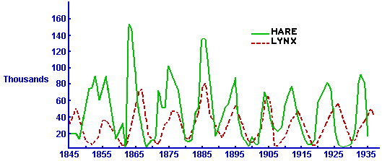

- According to the graph, the lynx population always lags behind the hare. Why does this happen?

- You will notice on the graph that the peak number of hare is always larger than the lynx. Explain this trend.

- What trophic level provides energy to the hare?

- What trophic level does the lynx occupy?

The lynx and hare simulation represents a predator-prey relationship but it is also a good example of the 10% Law discussed in the introduction. Referring to the information in the introduction, copy and complete the following diagram in your journal.

- If we assume that the producer has an energy capacity of 100%, label how much energy is then transferred to the hare, and the lynx.

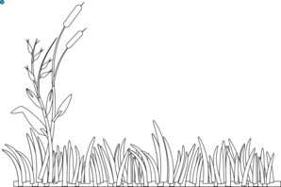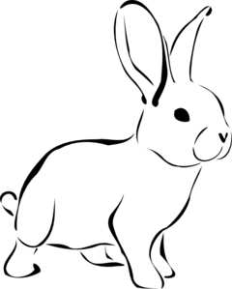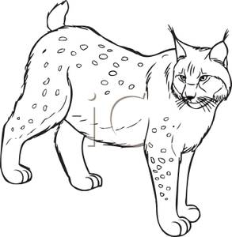

100% _______% _______%

- According to the simulation, each lynx was required to consume three hares in order to grow and reproduce. If each hare weighed 1.5 kilograms, how much grass must be consumed in order to meet the needs of the lynx?

- Why can there only be a maximum of 4 or 5 trophic levels?

Argumentation
Return to your original card sort and place your organisms in a food chain/web that demonstrates a realistic arrangement of trophic levels. Your instructor will give you another top predator to add to your arrangement. Using your white boards, describe how this change will effect the other trophic levels. It will be necessary to reference at least three of the activities from this exercise in your argument. Develop at least one question about food web dynamics to ask other groups as you share your white boards.

Abiotic Scenarios
Your group will be assigned an abiotic factor that could alter the dynamics of your ecosystem. Explain how this scenario would change the energy flow in terms of trophic levels, for your ecosystem. Be specific about how the change in energy would occur. This will include several connections between trophic levels and energy flow. You may need to use internet resources to complete this assignment. Be prepared to present your scenario to the class.

